**DAILY ONLINE ACTIVITIES SUMMARY**

|  |  |  |  |  |  |  |  |  |
| --- | --- | --- | --- | --- | --- | --- | --- | --- |
| **Date:** | **4/7/2020** | | | | | **Name:** | **Nivedita** | |
| **Sem & Sec** | **4th sem /A** | | | | | **USN:** | **4al18cs053** | |
| **Online Test Summary** | | | | | | | | |
| **Subject** | | **----** | | | | | | |
| **Max. Marks** | | **-----** | | **Score** | | | **---** | |
| **Certification Course Summary** | | | | | | | | |
| **Course** |  | | | | | | | |
| **Certificate Provider** | | |  | | **Duration** | | |  |
| **Coding Challenges** | | | | | | | | |
| **Problem Statement:** **Given an array of integer arr[] and an integer k, the task is to find the median of each window of size k starting from the left and**  **moving towards the right by one position each time** | | | | | | | | |
| **Status: done** | | | | | | | | |
| **Uploaded the report in Github** | | | | | **yes** | | | |
| **If yes Repository name** | | | | | [**https://github.com/nivi-nivedita/lockdown-coding-program**](https://github.com/nivi-nivedita/lockdown-coding-program) | | | |
| **Uploaded the report in slack** | | | | | **yes** | | | |

Certification Course Details: today I continued course in saylor.org

In that “computer science “.

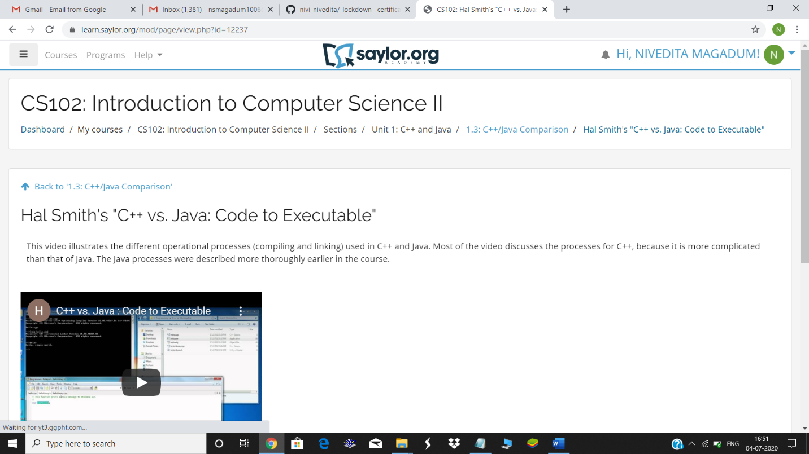

Coding Challenges Details: Given an array of integer arr[] and an integer k, the task is to find the median of each window of size k starting from the left andmoving towards the right by one position each time.Executed and uploaded.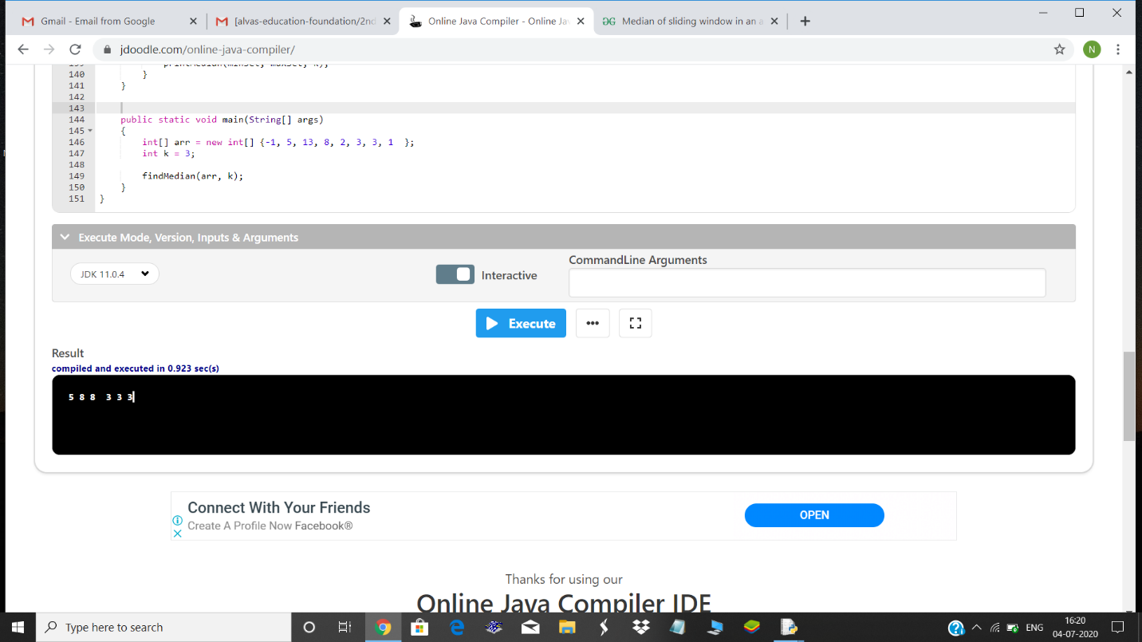

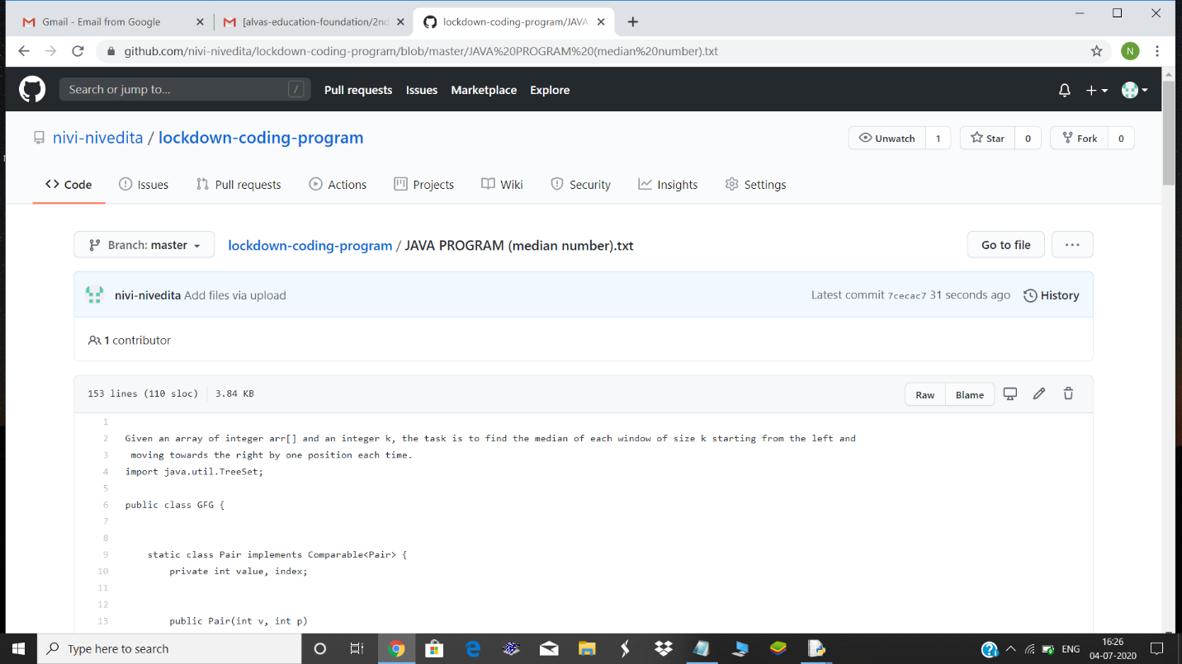

Today I attend online webinar(Aditya naik)

